**Cave Explorer**

**Goal**

The goal of the game is to reach the end of the level by completing various tasks. The game provides a framework so that goals can be added by the user. Therefore, the game provides a complete skeleton for students to fill it with what they desire the goal of the game to be. 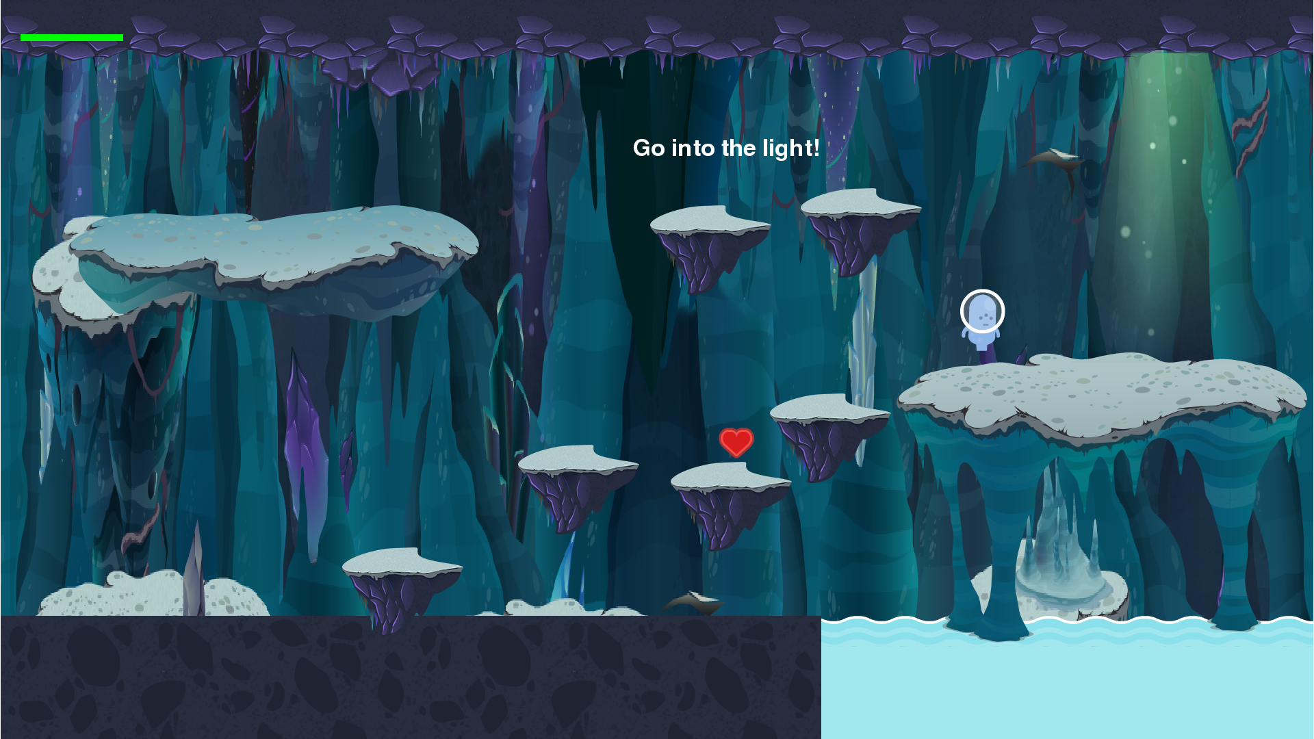

**Characters**

The player controls a character that interacts with other objects in the level in order to accomplish tasks. The interact key, “F”, is used to perform special actions depending on where the player is.

**Levels**

The levels within this game are easily created and modified in the Levels.py file. There are currently only 2 levels, but a new level can easily be made within minutes by using the map generator method.

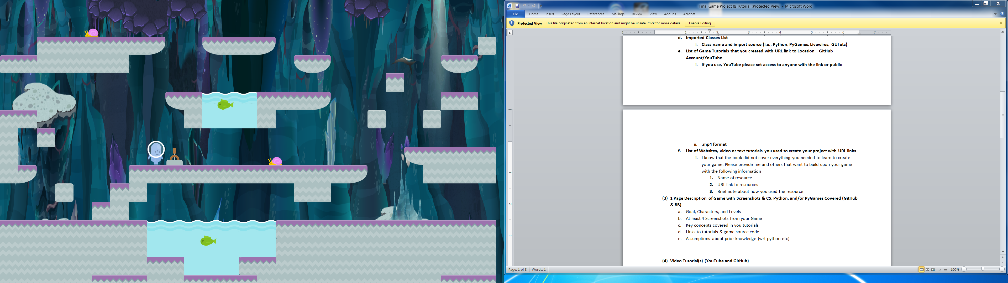

**Key Concepts**

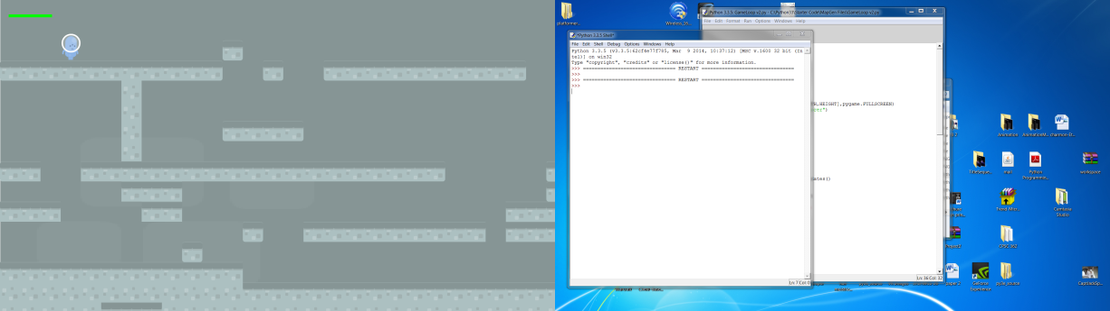The goal of my game is to get the user building levels and adding/modifying the content of that level quickly and seamlessly. In order to do that, the key concepts that I cover in my tutorials are how to create the tiles that you’ll use to build your level. Then, I cover how the map creation method works. Another concept I introduce is how to change levels in the game, so that by the end of the tutorial the user will be able to produce and play their very own level.

In order to create their level, students will find art from opengameart.org. The following picture shows the type of art you can expect to find and use:

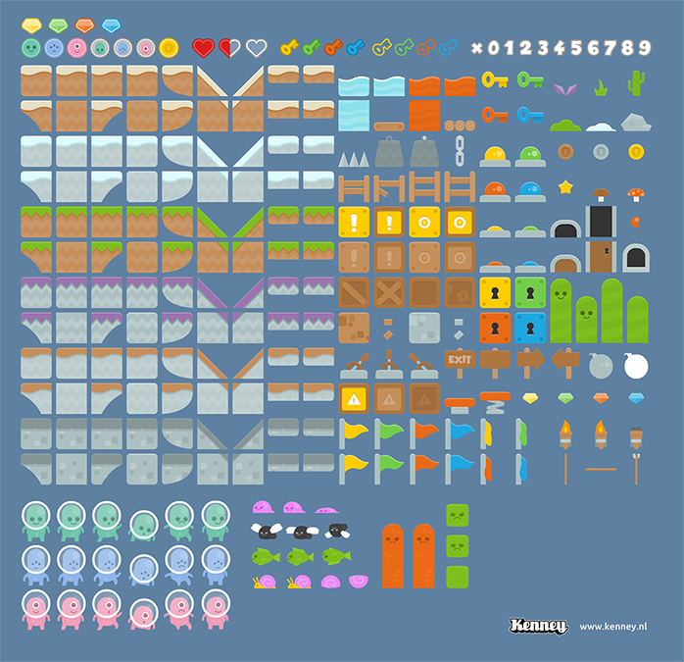

**Tutorials**

Video Order

1. Tiles Tutorial (2 parts)- <https://github.com/Cheyrenne/Tiles-Tutorial-code>
   1. LayeredUpdates (1 part) video at the same link
2. Changing Levels (2 parts) - <https://github.com/Cheyrenne/Changing-Levels-Tutorial>
3. Creating A Map (2 parts)- <https://github.com/Cheyrenne/MapGen-Tutorial>
   1. Level update video at same link

**Prior Knowledge**

The user needs to have an intermediate understanding of Python. Specifically, they need to know how loops work, classes and inheritance, and how functions behave.